Security auditing with lynis:
On linux server.

Steps:

Installing and running lynis:
- Intall lynis.
- Audit the server.
- Review the report.

Remediation:
- Address findings
- Update security policy

Installation of the lynis:
https://cisofy.com/lynis/#introduction
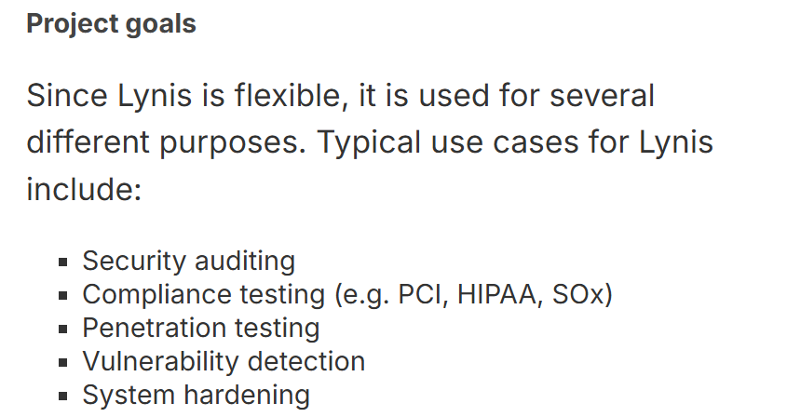

Here we use it for security auditing.
Demo:

Cd /opt/
# folder for extra software outside the core OS.
Sudo wget file_url.
Ls
Gzip -d file_name
# gzip = make files smaller (compress) or restore them (decompress).
Tar -xvf file_nmae
# tar (short for tape archive) is a Linux command used to combine multiple files/folders into one archive file
cd lynis
chmod +x lynis
./lynis - -help
./lynis audit system
# it take local system
For the specific policy auditing:
https://cisofy.com/lynis/controls/ # these are the lynis controls.
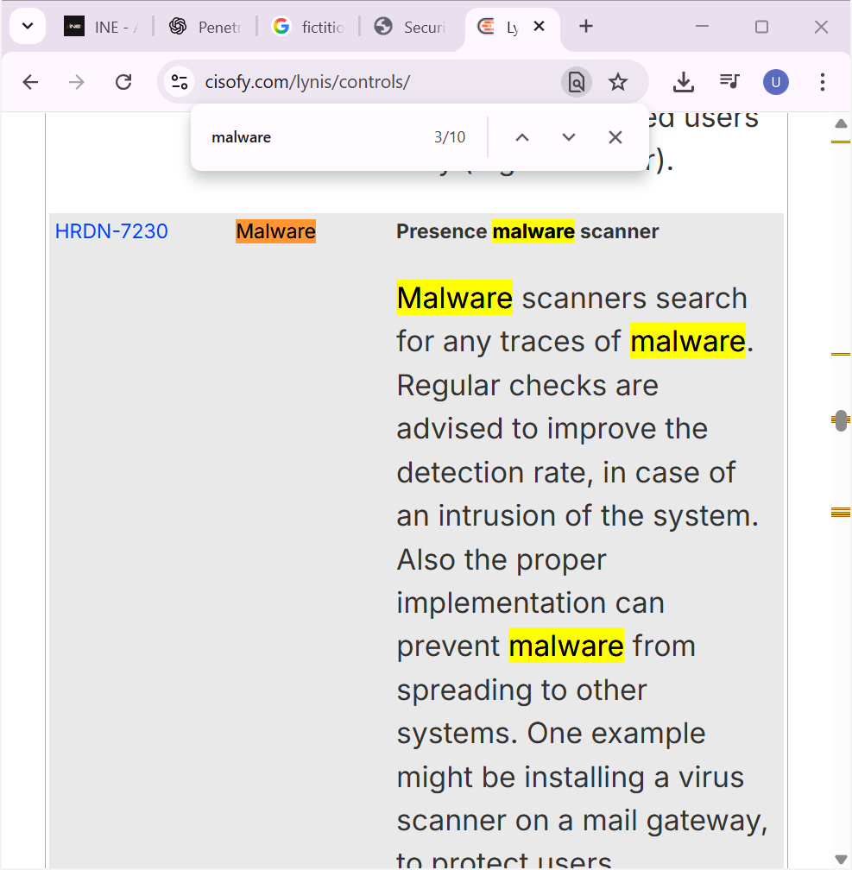

./lynis sudit system - -tests “HRDN-7230”
# this command only run this check

Save the audit file:
./lynis audit system - -auditor “ramu”
# Saves results and notes that the auditor’s name is ramu.

For quiet: (donot show anything on screen)
- - quiet

For quick: (skip something)
- - quick

NOTE:
Malware/ anti_malware scanner(linux):
Clamav

What is Lynis?
- Lynis is an open-source security auditing tool for Linux/Unix systems.
- It checks your system for vulnerabilities, misconfigurations, and compliance gaps.
✅ In short:
Lynis = “Doctor for your Linux system” 🩺 → it scans, finds weaknesses, and gives you advice to fix them.
Lynis output = warnings + suggestions + hardening score + system details.
It tells you what’s weak and how to fix it.
Command / Flag | What it does
lynis audit system | Run a full system audit (most common use).
lynis show help | Display help menu with all options.
lynis show commands | Show all available commands Lynis can run.
lynis update info | Check if a newer version of Lynis is available.
lynis plugins show | List installed plugins.
lynis --quick | Run a quick scan (fewer checks, faster).
lynis audit system --report-file /path/file | Save the audit results to a custom file.
lynis audit system --quiet | Run audit with minimal output (good for automation/scripts).

• --tests → run specific test(s)
• --auditor → save auditor name in report
• --quiet → no screen output
• --quick → faster scan, skips extras

NOTE:
/opt directory is used for optional software packages that are not part of the default operating system.
Cat /etc/*issue
Show the distribution of the system.

